SNO+: Neutrino detection facility and calibration simulations using RAT simulation software

*Abstract: This report talks about the functions that SNO+ provides and the section of the SNOLAB facility that specialises within the SNO+ experiment. Data drawn from ROOT simulations are used to analyse the accuracy of reconstruction at both different energy and range values. For 0 neutrino double beta simulations the results show that mean, sigma and chi square values seem to be consistent for low ranges with some unknown factor causing inconsistencies with the higher 2 range intervals. As for 2 neutrino double beta decay the results show that using energy only cuts that the algorithms used for reconstruction are most accurate at higher energy in terms of sigma and chi square while mean values show no noticeable pattern. By introducing both energy and range cuts results show that mean improves with energy at lower ranges and becomes more inconsistent at higher ranges while mean improves as range increases with the exception of range interval 5105.75mm – 5500mm where mean changes sign and becomes more inaccurate. Sigma is shown to improve with energy and be consistent over range except for the previously mentioned interval similarly chi square also improves with energy and remains roughly consistent over range except for the 5105.75mm – 5500mm range interval. By isolating the unknow factors within this range interval the reconstruction algorithms become more accurate making it possible to reduce the chi square value down to acceptable values for the energy range cut histograms [4][0], [4][1], [4][2] and [4][3] (energy cut 4, range cut 0,1, 2 and 3) to 34.7, 38.64, 45.14 and 45.18 respectively which lower than the statistical value for Chi square of 61.581 for 36 degrees of freedom, 62.883 for 37 degrees of freedom and 64.181 for 38 degrees of freedom and thus can be accepted as gaussian distributions.*

**Introduction**

**The Sudbury Neutrino Observatory (SNO)**

The Sudbury Neutrino Observatory is a large multi-purpose neutrino research facility constructed 6800 feet below Sudbury, Ontario, Canada within INCO’s Creighton mine [1] The original SNO was a heavy-water Cherenkov detector designed to discover neutrinos produced in the sun via fusion. Utilising 1000 tonnes of heavy water loaned from the Atomic Energy of Canada Limited (AECL) within the acrylic vessel the neutrinos react with the heavy water which produced flashes of photons via Cherenkov radiation. The photons are then detected by the array of 9600 photomultiplier tubes (PMTs) mounted on a geodesic support structure surrounding the heavy water vessel. Outside of this the acrylic vessel in submerged in regular water within a 30m cylindrical cavity which was excavated from the surrounding rock within the deepest part of the mine, these layers of rock help the shield the detector from cosmic rays which could cause false positives within the detector. The detector laboratory of the SNO+ facility is cleaned extensively in order to reduce background signals. The detector is so sensitive that vicious cleaning is required and as a result SNO+ boasts one of the cleanest labs worldwide.

Since then SNO has been in the process of being upgraded (hence SNO+) in the hopes of studying neutrino-less double beta decay through the use of the radioactive isotope Tellurium-130 which is described in greater detail below. SNO+ also has the secondary objectives to study different types of neutrinos which occur, more specifically from:

* Proton-electron-proton (PEP) and carbon-nitrogen-oxygen (CNO) cycles which occur within the sun in order to better understand the neutrino-matter interaction and solar composition which take place there.
* Beta decay of both uranium and thorium within the earth in order to study geoneutrinos.
* Beta decay of fission daughter products which take place within nuclear reactors, also known as reactor anti neutrinos, to better understand neutrino oscillations.
* Supernova neutrinos and anti-neutrinos which may serve as an early warning system should such a seismic event occur within our galaxy.
* Nucleon decay into neutrinos, which would indicate a baryon conservation violation.

As it stands SNO+ is currently in the process of being constructed using the previous SNO as of February 2017 [2]

**Acrylic Vessel (AV)**

The Acrylic vessel is a large 12m diameter, 5cm thick, sphere deep within the Creighton mine and is the scientific centre of SNO+. The sphere itself contains 800 Tonnes of liquid scintillator (see scintillator process for more info), 1700 tonnes of water to act an inner shielding and 5300 tonnes of water to act as outer shielding. The Entire sphere is surrounded by the array of 9500 PMTs which are 20cm in diameter and come equipped with light collectors that are able to increase its efficiency up to 70% . These PMTs are held in place by the PMT support structure: A large geodesic stainless steel frame 18m in diameter which encases the AV. Numerous ropes are fixed to the AV to keep the vessel in place. Previously the vessel only required suspension ropes but due to the change to Linear alkyl benzene (LAB), the liquid scintillator used with the new form of the SNO+ project is less dense than water used for the original SNO and causes a buoyancy issue thus as of January 2013 [2] multiple ropes have also been installed to anchor the AV down. The barrel shaped cavity that the AV situates is 22m in diameter at mid-point and in roughly 34m high. Carved from the norite rock the cavity is lined with 8mm thick polyurethane barrier which is impermeable to both water and radon.[3]

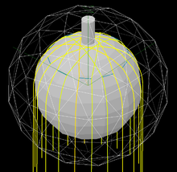Beyond this the AV requires extensive cleaning before any in depth test can be conducted. Any impurities within the AV has the potential to create false positives by generating undesirable noise which has the possibility to mask any true result. The sensitivity of the detector is so fine that any dirt brought in may be able to hide the very weak signals from neutrinos. The cleaning process has taken place in multiple stages during the upgrade process, most notably the interior cleaning of the AV was completed in April 2011 and the cleaning on the upper hemisphere was completed as of January 2013. Any individual who enters SNOLAB and by extension through the SNO+ facility must go through extensive cleaning, showering and different sets of clothing (such as changing from the miners outfit which is required by the Creighton mine to more hygienic clean-room outfits in order to enter.

Figure : the Acrylic Vessel

**The ${}_{ }^{130}{Te}$ Double beta decay and majorana particles**

Tellurium is a chemical element with an atomic number of 52 and is a brittle, silver-while metalloid, it shares many chemical properties to that of selenium and sulphur. It is a relatively rare element which is found within the Earth’s crust and has the comparative rarity to that of Platinum. Tellurium has 38 isotopes, the main interest of SNO+ focuses on the isotope of Tellurium-130 (${}_{ }^{130}{Te}$) which happens to be the most abundant form of Tellurium having an abundance of 34.08% [4]. It also boasts one of the longest half-lives of any naturally occurring radioactive nuclides with a half-life of $7.9x{10}^{20}y$ [5]. ${}_{ }^{130}{Te}$ Has the rare property of emitting radiation on the form of Double beta decay via the following process:

$${}_{ }^{130}{Te} →{}_{ }^{130}{Xe}+2e^{-}+2\overline{V_{e}}$$

Equation

Double beta decay can take two forms: ordinary and neutrinoless, in ordinary double beta decay the previously mentioned process takes place, resulting in the production of two electrons and two electron antineutrinos. The neutrinoless double form is a hypothetical process where (as the name suggests) no neutrinos are produced. The neutrinoless double beta decay was first proposed by Maria Goeppert-Mayer in 1935 and was further developed by Ettore Majorana who demonstrated that, if neutrinos were their own anti particle, later to be named the majorana particle, that all results will remain constant and the process can occur without the production of electron neutrinos. This lead to the development of the double beta neutrinoless decay. It is not yet known if this theoretical particle property exists as it is yet to materialise via engineering or to be found in nature. If neutrinos are to hold this Majorana property and at least one neutrino has a non-zero mass (which is required by previous neutrino oscillation experiments) then neutrinoless double beta decay is possible. As neutrinoless double beta decay violates the lepton number conservation other processes must also come into play, the simplest of which is known as light neutrino exchange: a nucleon absorbs an already emitted neutrino, neutrinos exchanged in this way are treated as virtual particles.

With only two electrons in this final state, the total energy of these electrons would be about equal to the binding energy difference between the initial and final states of nuclei with the nuclear recoil being equal to whatever remains.

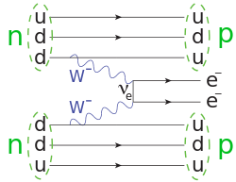[6]

Figure : Showing the standard double beta decay.

The decay rate for this process is given by

$$R=G {\left|M\right|}^{2}{\left|m_{ββ}\right|}^{2}$$

Equation

Where G is the two body phase space factor: A factor given by the probability of final states that can occur given the combination of possible momentum states, M is the nuclear matrix element, and $m_{ββ}$ is the effective Majorana mass of the electron neutrino. [7]

Therefore observing neutrinoless double beta decay will not only help to confirm the Majorana neutrino property, but can also provide information and insight on the absolute neutrino mass scale and Majorana phases. This discovery can also help theoretical models in matrix elements and decay models.

In order to account for the imbalance and the violation of lepton number Leptogenesis theories are introduced. In the current Standard Model lepton number is conserved. It is not possible to create leptons directly without corresponding antileptons thus Leptogenesis can therefore only take place beyond the Standard Model. Leptogenesis is one set of theories to help explain the abundance of leptons over anti-leptons which occurred in the early universe occurring shortly after the big bang, but can also be used to help explain neutrinoless double beta decay.

Using a small modification to the current standard model right-handed neutrinos are added: The helicity direction is in the same direction of its motion, likewise a particle is left handed if the directions of motion and spin are opposite. Experimental results show that in nearly all cases observed neutrinos are all left handed, while all anti-neutrinos have right handed helicities. Due to the theoretical Majorana properties the neutrino can be its own anti-particle in this way by having both left handed and right handed helicity within different frames of reference. Both these particles (particle and anti-particle) are related by complex conjugation. A neutrino is the only particle to potentially have this property due to its neutral charge, while all other fermions are believed to be Dirac fermions. By having this property the double neutrinos which were produced in the decay undergo spontaneous annihilation and thus the electrons which are produced in the reaction are given the maximum amount of energy, which is calculated to be 2.5 MeV From the SNO+ root files. By including right handed neutrinos the seesaw mechanism (used to understand the relative sizes of observed neutrino masses, compared to those of quarks and charged leptons, which are orders heavier) can be added providing the neutrinos with mass. At the same time, the modified model is able to spontaneously generate leptons from the decays of right-handed neutrinos, fixing the lepton number violation.

**Scintillation process**

A scintillator is either an organic (plastic or oil) or non-organic (crystal) material that experiences scintillation: a type of luminescence that when excited by ionizing radiation, such as photons with energies higher than green light photons, will absorb its energy and reemit it in the form of a visible light photon, usually either green or blue. It is possible that the re-emission can be delayed through metastable properties within the scintillator material.

A scintillation detector is created when a scintillator is combined with an electronic light sensor such as a photomultiplier tube (PMT), via the photoelectric effect the PMT is able to absorb the visible light photon which is emitted by the scintillator material and re-emit it in the form of many electrons. This is used to form an electronic pulse that can be analysed, as it will contains information about the initial photon energy, to produce useful findings.

The SNO+ experiment will use a liquid scintillator linear alkyl benzene (LAB) as the target material within the AV, in place of heavy water which was utilised by the original SNO. LAB has many useful properties such as:

* High optical transparency (≈20 m)
* High light yield
* Low amount of radioactive impurities
* Safe handling due to high flash point (the lowest temperature that a liquid will ignite)
* Available in large quantities from a local source
* Relatively low cost [8]

It is for these reasons that LAB has been selected to be the liquid scintillator used within the SNO+ experiment.

**PEP and CNO cycles plus Other types of neutrinos: geoneutrino, reactor anti neutrino, super nova neutrino and nucleon decay neutrinos.**

While the main focus of SNO+ is to look into neutrinoless double beta decay SNO+ has other focuses in other types of neutrino reactions that can occur. These studies can also provide great insight into the nature of neutrinos and there properties. For this reason the studies have been includes here in some detail, although this is not the focus of the report.

**PEP and CNO**

Proton-proton chains is one of the known two reactions that occur within the sun and mainly applying the small size stars. A series of reactions occur where protons will fuse together to create helium, during of which will produce electron neutrinos which are emitted. It is possible to detect these neutrinos on Earth given that they are able to survive the transition. The likelihood that the neutrinos survive is related to the energy that they receive during the beta plus decay when converting from a diproton to deuterium:

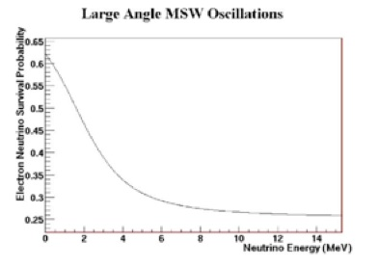[9]

Figure : The likelihood that a neutrino created in the sun will reach Earth given its energy.

SNO+ is interested in looking into the transitioning area between 1-4 MeV. Being able to observe the change in survivability within this region would confirm the MSW mechanism: This region is the most sensitive place to look for sub-dominant effects (between the matter and vacuum oscillation dominated areas) in neutrino oscillations. Due to the depth of SNO+ which shields it from the effects of cosmic rays, it is currently the only viable facility that can accurately measure of the PEP neutrino flux. By searching for the shape of the “PEP recoil electron energy shape” [10] SNO+ can measure the solar neutrino flux and the electron neutrino survivability at 1.4 MeV, making it possible to study potential new physics and further the understanding of neutrino oscillations.

In combination with PEP a small percentage of a stars energy is also produced via the CNO (Carbon Nitrogen Oxygen) cycle. This contribution is widely understudies due to the difficult nature of its predictability. Measurements by SNO+ of the previously mentioned flux of neutrinos, produced within the CNO cycle would tell of the CNO contribution to solar energy generation and allow for a greater understanding of the suns processes below its surface.

**Nucleon decay**

Grand Unified Theories (GUTs) seek to join different classes of particles (baryons, leptons, etc.) allowing one type to convert into another. GUTs predict that protons or neutrons are unstable and can decay into light particles so as to decrease the number of quarks and produce more leptons. Such an event would be incredible rare, with typical timescale for a single event being ${10}^{30}$ years, however given the large amount of protons and neutrons located within the detector it may be possible for SNO+ to detect such a decay by chance. As of yet no evidence for such baryon violating events have occurred leading to theories that propose that it is possible for baryon number violation to occur through different methods, current neutrino detectors are not sensitive enough to detect such events or due to the relatively unclear nature of these decays makes them significantly harder to detect. If the last option is a possibility and as such no easily visible particles are produced from a proton or neutron decay it may be possible to indirectly record as event by monitoring the “loss of the proton or neutron that decayed. A main example of this is that should a neutron from an oxygen atom “vanish” the change in energy of that atom as it restructures itself is calculated to be around 6 MeV that would materialise in the form of a gamma ray which could be found by the detector.

**Supernova neutrinos**

When a star within the magnitude of 8-40 solar masses collapses a type II supernova explosion occurs. When such an event happens more than 99% of the stored gravitational binding energy is released as neutrinos which is then ejected into the cosmos. The amount of neutrinos that are produced in these few seconds is greater than the production of neutrinos the star has produced in its lifetime up to this point, resulting in a large flux of neutrinos predicted to be evenly distributed among its 3 flavours and matter/anti-matter constituents. The flux produced is large enough to be detected from within our own galaxy and set off a large number of events within SNO+ as well as many other neutrino detectors around the Earth simultaneously. An example of this is supernova 1987A: produced 50kpc away was detected by the Kamiokande, IMB and Baksan neutrino detectors within 13 seconds of each other. [11] SNO+ would, once fully up and running, would also be useful as a supernova detector. If such an event was to occur when while SNO+ was running the flux could be used to study both neutrino and stellar physics, including testing neutrino oscillation models, setting limits on neutrino mass and studying possible compact dimensions.

**Geo-neutrinos**

Anti-neutrinos that are emitted from radioactive isotopes from within the Earth’s crust are also of scientific interest to SNO+. The main source of these anti neutrinos come from the beta minus decay of ${}_{ }^{40}K$, ${}_{ }^{238}U$ and ${}_{ }^{232}{Th}$ and give an indication to the geological make up of the Earths crust and mantel as such a reaction constitutes for a large fraction of the heat produced within the Earth and as such indicates how the Earth has cooled over time. SNO+ is located in an ideal settlement to study geo-neutrinos due to the continental crust around Sudbury containing a higher concentration of radioactive elements and should be able to provide greater results for studying the geo-neutrino flux than other neutrino observatories such as KamLAND. [12]

**Reactor neutrinos**

SNO+ is also able to monitor the neutrino flux of nuclear reactors which produce a large and constant output of electron anti neutrinos as a by-product of its power generating process. The process itself in known and is linked to both the rate of neutrino production and the anti-neutrino spectrum it is associated with. Having such well-defined parameters (both flux and spectrum) produced a known distance away from the detector makes for a very powerful way to determine the characteristics of neutrino oscillations. As the reactions that occur within the reactor are beta plus decays there is a very strong relationship between the positron produced and its associated electron anti-neutrino that makes measuring anti-neutrino spectra relatively easy with a scintillator. As these anti-neutrinos propagate through the earth they undergo vacuum oscillations allowing some of these anti-neutrinos to change flavour into tau or muon anti-neutrinos. This is comparable to solar neutrinos where the likelihood of changing flavour occur relates to its survival probability as a function of energy. [13] Due to this potential flavour change the spectra of electron anti-neutrinos will vary at different locations depending on the distances from the original reactor making them comparable and of interest to study.

**Background Radiation**

The depth of SNO+ and the 2km of rock between the lab itself and the surface is what allows for such experiments to happen due to the shielding nature of SNO+ experiments location. In combination with the depth the facility also includes designs and procedures in order to minimalize background radiation as well as other sources of interference. This is most true within the SNO detector itself being constructed from materials which have been carefully constructed for their low ${}_{ }^{238}U$ and ${}_{ }^{232}{Th}$ properties. The levels of both Uranium and thorium within the surrounding rock are approximately about ${10}^{-6}$ grams per gram of norite rock. By careful construction and selection the levels within the PMTs and the supporting structure are approximately ${10}^{-4}$ grams per gram and the AV itself where the sensitivity is at its highest contains approximately ${10}^{-12}$ grams per gram. In addition the detector has been both constructed and maintained under ultra-clean conditions. The air in in the facility is heavily filtered to remove impurities and the workers must wear clean-room clothing to reduce contamination to maintain air quality on the order of class 2000 (2000 particles of size 0.5 µm or larger permitted per cubic foot of air). A high performance water purification system is also in place to reduce the levels of ${}_{ }^{238}U$ and ${}_{ }^{232}{Th}$ to less than $1 × {10}^{-14}$ grams per gram of water. The PMT structure which is surrounded by the previously mentioned 8mm thick polyurethane barrier is 99.9% impermeable to water and allows for good water flow between the inner and outer shielding regions. In the outer regions the water is removed, filtered for impurities such as radon and is then reinjected back into the inner region. Allowing for a lower level of radioactivity in the regular water inner region in comparison to the outer region. With all these features in place the background radiation from the walls is reduced to approximately 70 muons a day.[14]

**Monte Carlo method**

Monte Carlo simulations was first used by scientists working on the atomic bomb and named after a Monaco resort town known for its casinos. Monte Carlo simulations is a computerized mathematical technique which allows you to see every possible outcome as the results of different decisions and parameters. This method is often used in a wide range of sectors that incorporate risk such as the finance sector and investments or building developments in rough terrain, for example Monte Carlo can be used to assess the damage to buildings, resources and human life during natural disasters in different areas given the parameters of the area (strength of earthquake, epicentre location, use of dampeners on buildings etc.) giving a range of different outcomes and the linked probabilities. Monte Carlo also shows the extreme possibilities, which in the context of SNO+ is able to generate and simulate the neutrinoless double beta decay within the acrylic vessel. [15]

The software and analysis tool RAT is a variant of ROOT: a software code similar to that of c++ which is used specifically in the particle physics field. RAT has been specifically developed for SNO+ using Mote Carlo to artificially create reactions within the AV. In combination with this RAT will also simulate how well the system (PMTs, the accompanying hardware and software etc.) is able to recreate the simulated events. This is done in order to calibrate and fine tune the SNO+ experiments and is the main focus of this report: how well RAT and SNO+ is able to reconstruct the simulations generated and compare both the initial Monte Carlo simulations with the reconstructed Monte Carlo events using a variety of mathematical algorithms. This will be done by comparing the true parameters of the Monte Carlo events in terms of its energy and position with the results of the reconstruction algorithms. Each time a set of MC events are generated, reconstructed and analysed the RAT software is able to update and fine tune its algorithms in order to give more accurate results [16] [17]

**Analysis**

This section and henceforth will be performing analysis on the events which are generated by the simulations within the acrylic vessel. The events in question are randomly generated within 5.5m of the AV centre and will have an energy value somewhere in the range of 0-2.5 MeV. These values will apply to the two electrons which would be generated during the double beta decay. Because of the nature of the reaction the kinetic energy is split between the two electrons and the two anti-neutrinos with the share that each particle receives varying with the maximum amount being 2.5 MeV and hence the range in energy. The range of 5.5m instead of the full 6m radius of the AV is used as there is difficulty simulating events past this point and so a fictitious boundary has been placed at this value.

The energy values used within the following graphs refer to $(energy-MCEdepQuenched)/MCEdepQuenched$ where energy is the reconstructed energy: the value returned by RATs fitting algorithms as the most likely energy for that event based on observed properties such as PMT hits. MCEdepQuenched refers to the simulated energy deposited into the scintillator taking quenching into account. By using $(energy-MCEdepQuenched)/MCEdepQuenched$ the graphs will show how accurate the algorithms are in reconstructing the energy that they are given in terms of a percentage value and hence will take into account the proportionality of each of the differences over the total true energy, this will be done by comparing and analysing the accuracy at different energy and range cuts as well as looking into mean, sigma and chi square of these functions when modelling the distribution over a gaussian.

These analysis will be conducted for both 2 neutrino double beta decay (0nββ) and 0 neutrino double beta decay (0nββ). As 0nββ will have a fixed energy value of 2.5 MeV it cannot be divided into energy intervals and thus will only be analysed over different ranges.

Energy cuts: the energy has a total range of 0-2.5 MeV and divided into sets of 5 covering 0.5 MeV each:

|  |  |  |
| --- | --- | --- |
| Energy cut | Energy Range (low – high) (MeV) | Energy centre (MeV) |
| 1 | 0 – 0.5 | 0.25 |
| 2 | 0.5 – 1.0 | 0.75 |
| 3 | 1.0 – 1.5 | 1.25 |
| 4 | 1.5 – 2.0 | 1.75 |
| 5 | 2.0 – 2.5 | 2.25 |

Table : Energy cuts for created histograms

Range cuts: The AV has a full radius of 6m however it is difficult to reconstruct events close to the edge of the AV and as a result a fictitious radius limit of 5.5m. With the new limit of 5500mm the radius is divided into 5 shells giving equal volume. This translates to the range of the shells being:

|  |  |  |
| --- | --- | --- |
| Volume shell | Range (low – high) (mm) | Range centre (mm) |
| 0 | 0 - 3216.42 | 1608.21 |
| 1 | 3216.42 - 4052.43 | 3634.43 |
| 2 | 4052.43 – 4638.88 | 4345.66 |
| 3 | 4638.88 – 5105.75 | 4872.31 |
| 4 | 5105.75 - 5500 | 5302.87 |

Table : Energy and range cuts for created histograms

On the graphs that will be generated this are notated by the number given within the key in the order of [energy cut number][range shell number] for example hist12 will notate a histogram produced used the first energy cut (0 – 0.5 MeV) with the second range shell (3216.42 – 4052.43 mm).

**Analysis part one: 0 neutrino double beta decay analysing the full spectrum and range cuts only**

The first part of the 0 neutrino double beta decay analysis is to study how the reconstruction behaves over the full spectrum:

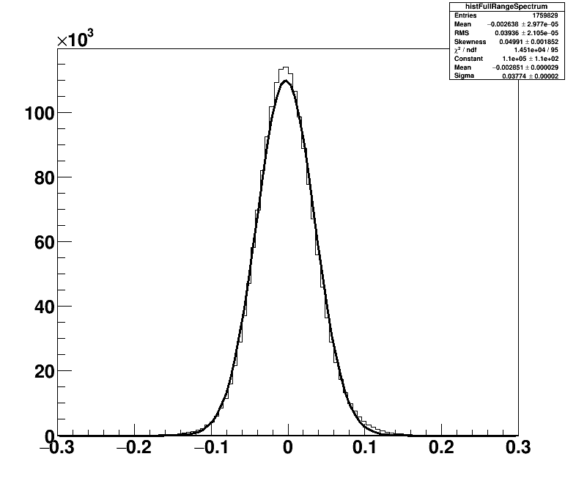

**Entries**

**Energy (MeV)**

Figure : 0n2B distribution over the full spectrum.

Figure 4 gives a baseline of what to expect for future graphs and can be used for comparison. Figure 4 shows a negative mean value of -0.002851 MeV ± 0.000029 MeV and a sigma value of 0.03774 MeV ± 0.00002 where the distribution tends to 0 entries at around ±0.7 MeV. Figure 4 also comes with a very high chi square value of $1.1 × {10}^{4}$ with 95 degrees of freedom showing that this distribution is not suitable for a gaussian fit. Further analysis will be conducted to study these factors and cuts will be made in order to pin point and isolate factors that negatively effect these values.

Due to the nature of neutrinoless double beta decay energy is fixed at around the 2.5 MeV as the energy produced within the reaction is not divided between the electrons and the neutrinos produced with the energy going solely to the electrons which then go on to be artificially detected by the PMTs. As such only range is divided into intervals and the analysis will be performed by comparing these results over these ranges. Due to the neutrinoless decay being much more rare compared to its 2 neutrino decay counterpart significantly less entries are recorded and as such the results shown may be less reliable than the 2 neutrino simulations.

The table below compares the graphs produced which are used with a ±0.3 MeV energy range in order to be consistent with the energy only cuts used for 2 neutrino simulations.

|  |  |  |  |  |  |
| --- | --- | --- | --- | --- | --- |
| Graph | Entries | Mean (MeV) | Sigma (MeV) | Skew | Chi square/ndf |
| Hist0 | 275562 | -0.005009 ± 0.000062 | 0.03233 ± 0.00004 | 0.04371 ± 0.004667 | 145.1/48 |
| Hist1 | 275102 | -0.002616 ± 0.000062 | 0.03234 ± 0.00004 | 0.04656 ± 0.004671 | 148.4/51 |
| Hist2 | 274934 | -0.002344 ± 0.000062 | 0.03264 ± 0.00004 | 0.03843 ± 0.004672 | 94.81/49 |
| Hist3 | 275833 | -0.005851 ± 0.000064 | 0.03335 ± 0.00005 | 0.03902 ± 0.004665 | 121/55 |
| Hist4 | 275976 | 0.00008441 ± 0.0000792 | 0.04065 ± 0.00006 | 0.1687 ± 0.004665 | 1652/78 |

Table : A comparison of mean, sigma and chi square values over 5 range intervals for 0n2β.

Table 3 in combination with the figures 5, 6 and 7 below that comparing mean, sigma and chi square are analysed and provide an insight to the accuracy of the simulations for 0n2β decay:

* Entries are very consistent across each of the range intervals, showing that the events being simulated are evenly distributed.
* Mean seems to show an upwards trend starting at a negative value before passing through the ideal value and becoming positive for the final range value. It appears that some factor within the upper ranges would cause the mean value to deviate from zero causing a large mean value for range point 4 and then a flip in sign for range point 5.
* Sigma and chi square appears to remain fairly consistent for the lower ranges before increasing exponentially within the higher ranges
* Skewness is positive and consistent across each range cut this shows that reconstruction has a preference for generating a lower energy than the initial true energy and that skewness is unaffected by range.
* The chi square values produced for the first 4 range intervals are almost low enough to be accepted as gaussian like distributions. These chi square values must be lower than a statistical value of 76.969-85.749 depending on the degrees of freedom for 5% significance.

These values seem to show more consistent results when in the lower ranges with some unknown factor causing more inconsistencies within the higher ranges between 4638.88mm and 5500mm. In order to gain more accurate results and be better able to isolate the factors which seem to be causing inconsistencies within the higher ranges energy must also be taken into account. This is done within the 2 neutrino double beta decay section of the analysis.

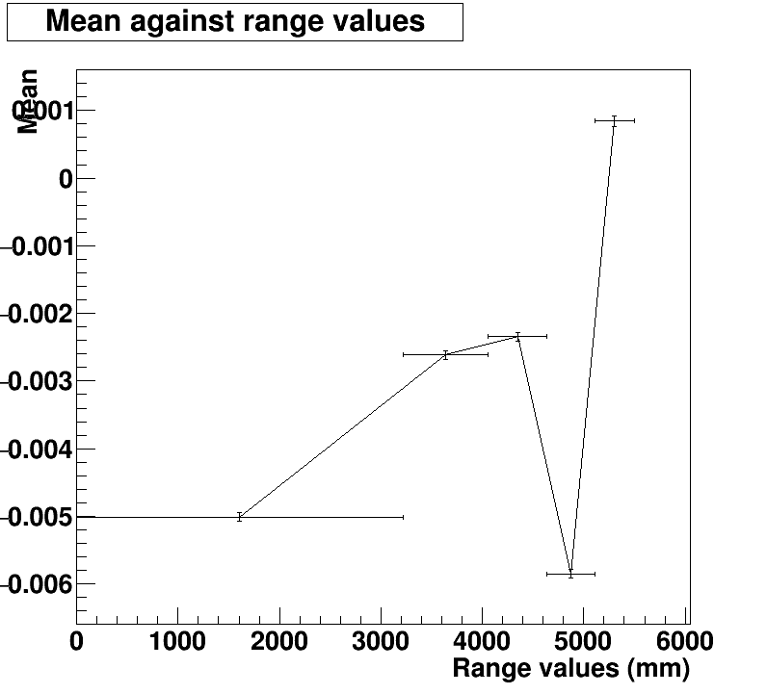

Figure : Mean against range for 0n2β simulations.

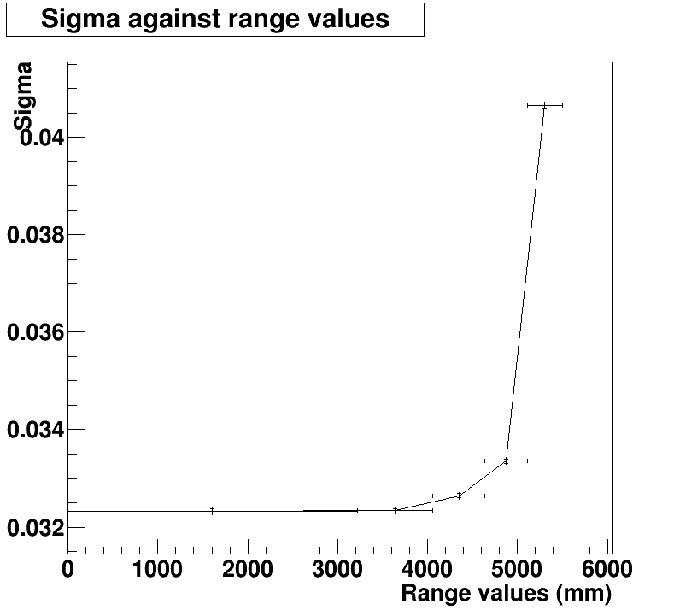

Figure : Sigma against range for 0n2β simulations.

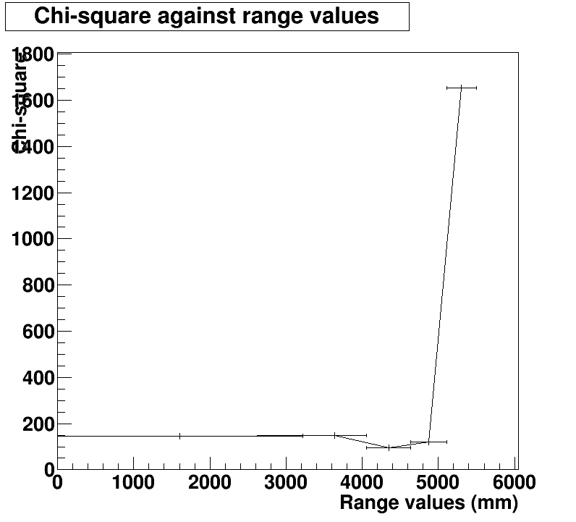

Figure : Chi square against range for 0n2β simulations.

**Analysis part two: 2 neutrino double beta decay simulations using energy only**

The first stage is to look at the overall distribution given its energy. How accurate the reconstruction is based on energy over the full energy spectrum:

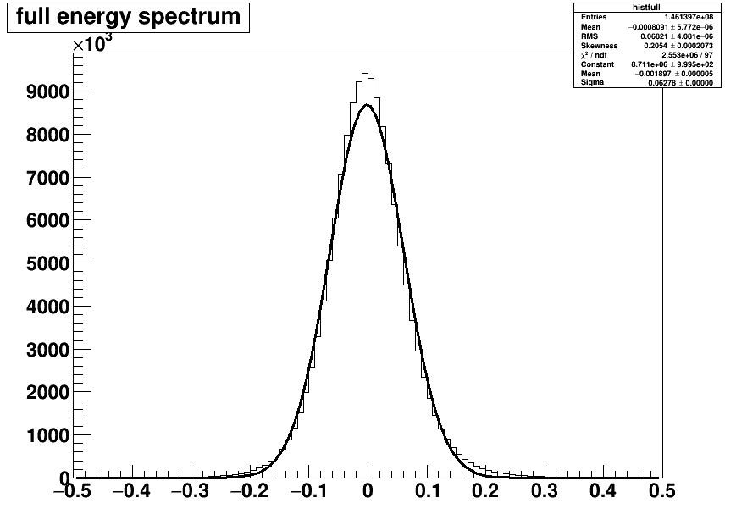

**Energy (MeV)**

**Entries**

Figure : A broad histogram showing the reconstructed energy minus Monty Carlo simulated energy compared against a gaussian.

Here figure 8 shows a total of $1.461397×{10}^{8}$ entries giving a gaussian like distribution centring around a mean of -0.001897 ± 0.000005 MeV showing that there is a slight negative shift within the energy reconstruction across the full spectrum. This is to be somewhat expected as energy will inevitably be lost within a system and it is likely that some energy will be lost within the AV either as heat, collisions with other particles or simply not meet the threshold requirements in order to register as a hit within the PMTs, This negative mean value may show that the algorithms used in order to reconstruct such energies may not fully compensate for the energy loss within the system.

From figure 8 while visually the curve follows a pattern similar to that of the gaussian the peak and tails have a noticeably higher concentration of entries. This is made more apparent by the following figure 9 and figure 10 below. By reducing the range to ±0.3 MeV for both figures and using a log y scale for figure 10:

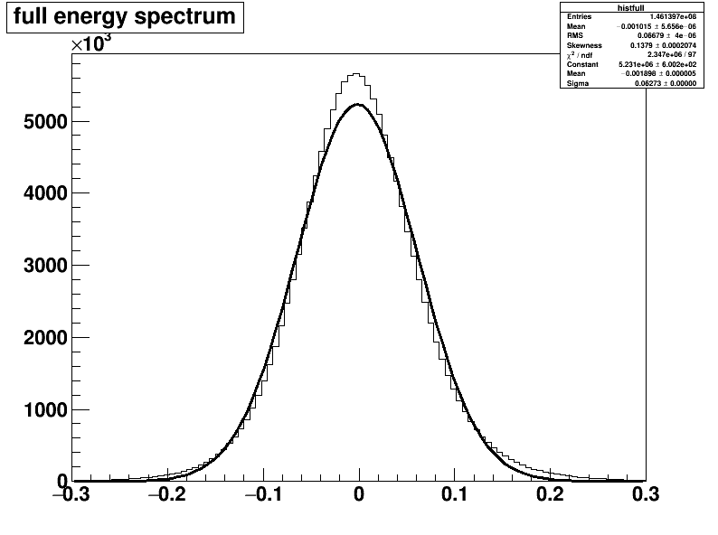

**Energy (MeV)**

**Entries**

Figure : Reconstructed energy minus Monty Carlo simulated compared with a gaussian with a reduced range of ±0.3 MeV.

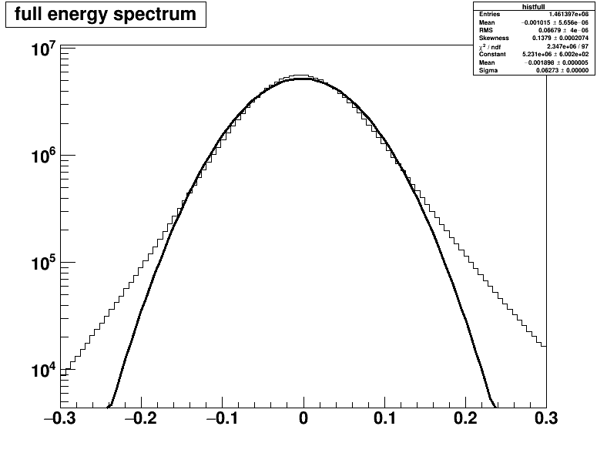

**Energy (MeV)**

**Entries**

Figure : Histogram 2 logged in the y axis to show more prominently the differences between the distribution and the gaussian, particularly at the end ranges.

Here it becomes visually more apparent how poor of a fit the gaussian fit is by comparing it to the reconstructed histogram. This is shown in its most apparent form with the figures 9 and 10 above:

* Figure 9 emphasises the poor gaussian fit around the central peak at and around 0 MeV. The Peak in question shows a higher concentration of entries where the Energy is very similar to that of the Monte Carlo reconstruction value. This would naturally suggest a good sign of accurate reconstruction and a narrower distribution.
* Figure 10 emphasises the poor gaussian fit around the tail ends at around $±$ 0.3 MeV. The higher amount of entries at the tails suggests a wider distribution than hoped for when comparing the energy and the Monte Carlo reconstruction values. These values will help negate the otherwise suggested good reconstruction accuracy that was previously mentioned for figure 9.
* The values in between these two points (the peak and the tails) is be close but ever so slightly lower than the gaussian distribution, which is a given by the laws of distribution.
* These distributions and deviations are investigated statistically below and investigated whether or not they are accurate given the number of degrees of freedom.

Statistically the poor fit is shown by its chi square value of $2.553×{10}^{6}$/97 and $2.347×{10}^{6}$/97 for figure 8 and figures 9 and 10 respectively. Although the accuracy of chi square is improved slightly by reducing the range to ±0.3 MeV as by doing so cuts out low levels of entries that are beyond this value. These values can be seen by extrapolating beyond ±0.3 for figure 10. These chi square values are magnitudes higher that the statistical value of 126.619 for 97 degrees of freedom (5% significance). Extending on this the chi squared value is extracted for each of the previously mentioned points of interest and compared in table 3 below using the equation:

$$X^{2}=\frac{{(x_{o}-x_{g})}^{2}}{σ_{o}}$$

Equation : Chi square equation using sigma

|  |  |  |  |
| --- | --- | --- | --- |
| Area of Interest | Observed value | Gaussian value | $$X^{2}$$ |
| Peak (0 MeV) | $$5.63 × {10}^{6}$$ | $$5.22 × {10}^{6}$$ | $$7.08 × {10}^{7}$$ |
| Tail (-0.2 MeV) | $$9.0 × {10}^{4}$$ | $$3.8 × {10}^{4}$$ | $$9.01 × {10}^{6}$$ |
| Tail (0.2 MeV) | $$1.1 × {10}^{5}$$ | $$3.0 × {10}^{4}$$ | $$1.93 × {10}^{7}$$ |
| Left curve (-0.1 MeV) | $$1.4 × {10}^{6}$$ | $$1.48 × {10}^{6}$$ | $$5.41 × {10}^{6}$$ |
| Right curve (0.1 MeV) |  |  |  |

Table : Chi-square values at areas of Interest

Given these values the chi square is still far too large to suggest that the gaussian is a good fit, however table 4 does provide some useful information for analysis:

* The difference in chi square values from opposing sides (ie -0.1 MeV and 0.1 MeV or -0.2 MeV and 0.2 MeV) give an indication to the shift that the distribution has undergone, These differences on opposite sides of the graph become slightly more apparent towards the tail end of the graphs, showing that the gaussian becomes a poorer fit further out away from 0 MeV. This suggest that the curve has been shifted to the left and is supported by having an overall mean of -0.001898 MeV.
* The left side of the curve (tail and left curve) while still inaccurate, are a better fit than elsewhere within the distribution.

Using this date it is concluded that using the full energy range is not suitable for a gaussian distribution. In order to take a more detailed look into these values the range on these values must be restricted further. As mentioned previously this will be done as explained by table 1.

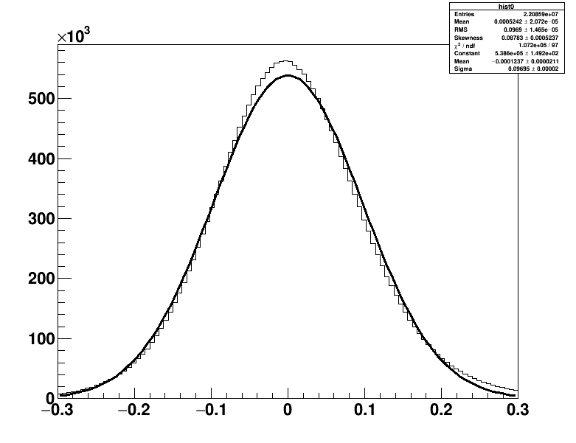

**Energy (MeV)**

**Entries**

Figure : Reconstructed energy minus Monty Carlo simulated given as a percentage (divided by true energy) compared with a gaussian with a reduced range of ±0.3 MeV with an energy cut of 0-0.5 MeV.

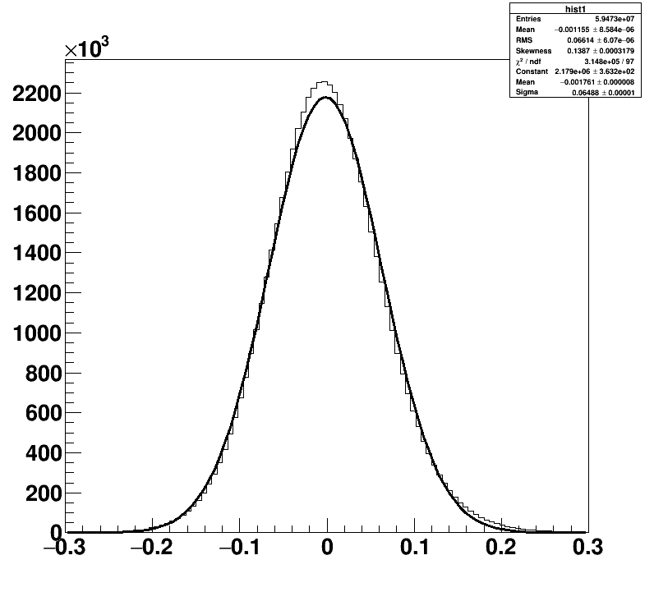

**Entries**

**Energy (MeV)**

Figure : Reconstructed energy minus Monty Carlo simulated given as a percentage (divided by true energy) compared with a gaussian with a reduced range of ±0.3 MeV with an energy cut of 0.5-1.0 MeV.

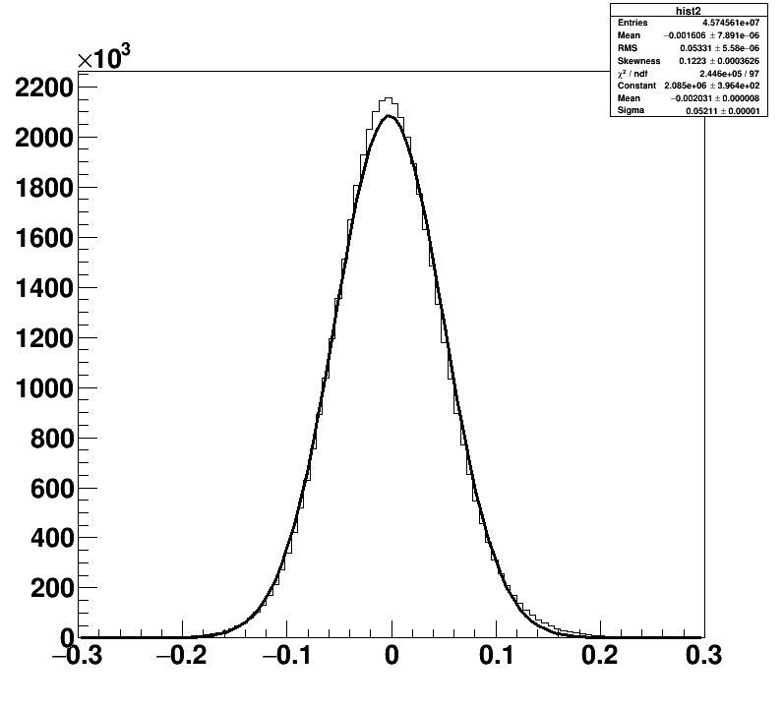

**Entries**

**Energy (MeV)**

Figure : Reconstructed energy minus Monty Carlo simulated given as a percentage (divided by true energy) compared with a gaussian with a reduced range of ±0.3 MeV with an energy cut of 1.0-1.5 MeV.

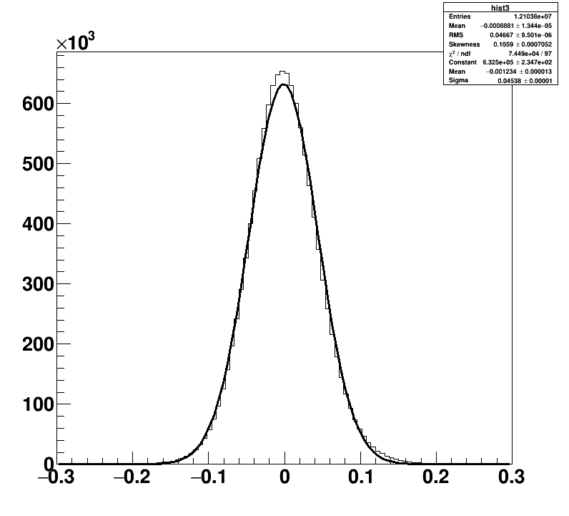

**Entries**

**Energy (MeV)**

Figure : Reconstructed energy minus Monty Carlo simulated given as a percentage (divided by true energy) compared with a gaussian with a reduced range of ±0.3 MeV with an energy cut of 1.5-2.0 MeV.

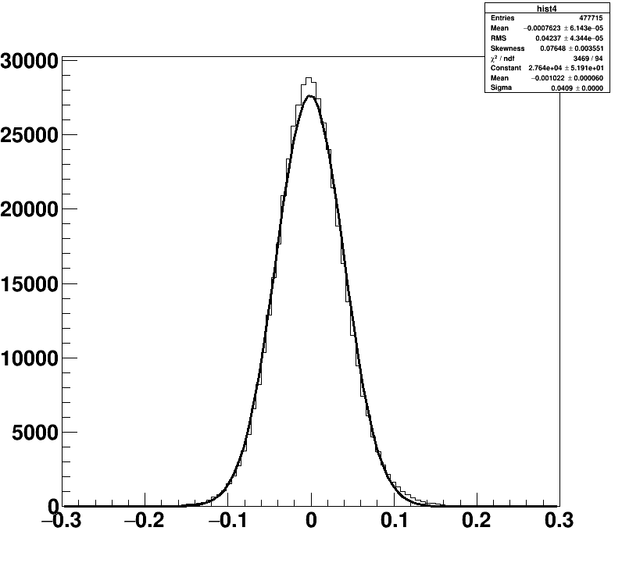

**Entries**

**Energy (MeV)**

Figure : Reconstructed energy minus Monty Carlo simulated given as a percentage (divided by true energy) compared with a gaussian with a reduced range of ±0.3 MeV with an energy cut of 2.0-2.5 MeV.

|  |  |  |  |  |  |
| --- | --- | --- | --- | --- | --- |
| Graph | Entries | Mean (MeV) | Sigma (MeV) | Skew | Chi square/ndf |
| Hist0 | $$2.21 ×{10}^{7}$$ | $$-1.237 × {10}^{-4}±2.11 × {10}^{-5}$$ | $$0.09695 ±0.00002$$ | $$0.8783 ±5.237 × {10}^{-4}$$ | $1.072 ×{10}^{5}$/97 |
| Hist1 | $$5.95 ×{10}^{7}$$ | $$-1.761 × {10}^{-3} ±8 × {10}^{-6}$$ | $$0.06488 ±0.00001$$ | $$0.1387 ±3.179 × {10}^{-4}$$ | $3.148 ×{10}^{5}$/97 |
| Hist2 | $$4.57 ×{10}^{7}$$ | $$-2.031 × {10}^{-3} ±8 × {10}^{-6}$$ | $$0.05211 ±0.00001$$ | $$0.1223 ±3.626 × {10}^{-4}$$ | $2.446 ×{10}^{5}$/97 |
| Hist3 | $$1.21 ×{10}^{7}$$ | $$-1.234 × {10}^{-3} ± 1.3 × {10}^{-5}$$ | $$0.04538±0.00001$$ | $$0.1059 ±7.052 × {10}^{-4}$$ | $7.449 ×{10}^{4}$/97 |
| Hist4 | 477715 | $$-1.022 × {10}^{-3} ±6 × {10}^{-5}$$ | $$0.0409 ±0.0000$$ | $$0.07648 ±3.551 × {10}^{-3}$$ | 3469/94 |

Table : Summary of energy only histogram cuts.

Here the three previous graphs show the distribution of the energy recreation accuracy for different energy ranges. By breaking the results into these sub sections a few patterns emerge:

1. The width of the distribution decreases when moving to higher energy intervals, the first histogram (figure 11) distribution appears to drop to 0 at around 0.3 MeV, the second (figure 12) at around 0.26 MeV, o.2 MeV, 0.18 MeV and 0.16 MeV for figures 13, 14 and 15 respectively. Showing that the reconstruction is more accurate (and gives a smaller distribution) at higher energy levels.
2. The number of entries appears to be clustered towards the first 4 shells of the acrylic vessel with significantly fewer values at the 2.0-2.5 MeV interval. This has a direct effect on the reliability of hist4.
3. The mean shows a dip in accuracy towards the central histograms appearing to be most inaccurate at hist2.
4. Sigma value decreases when moving to higher energy ranges.
5. Skew shows a pleasant downwards trend as the energy interval increases, suggesting that the distribution becomes more even as energy increases.
6. Chi square decreases, thus gaussian distribution becomes a better fit when moving to higher energy intervals.

This analysis is backed up visually by the graphs below displaying the Mean, Sigma and Chi-square plotted against energy respectively.

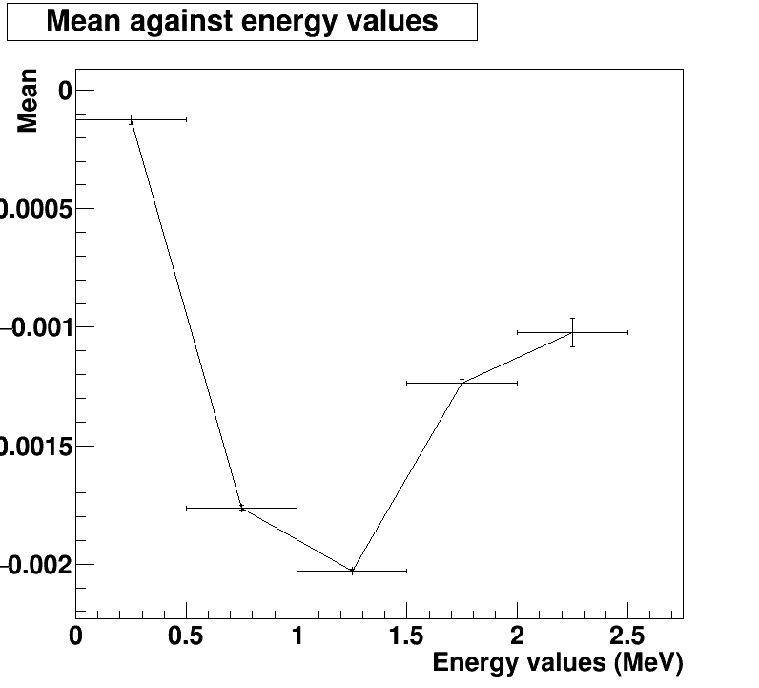

Figure : A comparison of Mean against energy values (MeV) for energy only cuts.

The mean against energy shows a dip in accuracy towards the centre of the energy distribution. The most inaccurate being that of hist2 at a mean value of $2.031 × {10}^{-3}±8 × {10}^{-6}$ MeV and suggests a Plato at around the -0.001 MeV mark. However 5 points is not sufficient enough to make any reliable predictions. In order to make a reliable observation about a potential tend to value more points must be included.

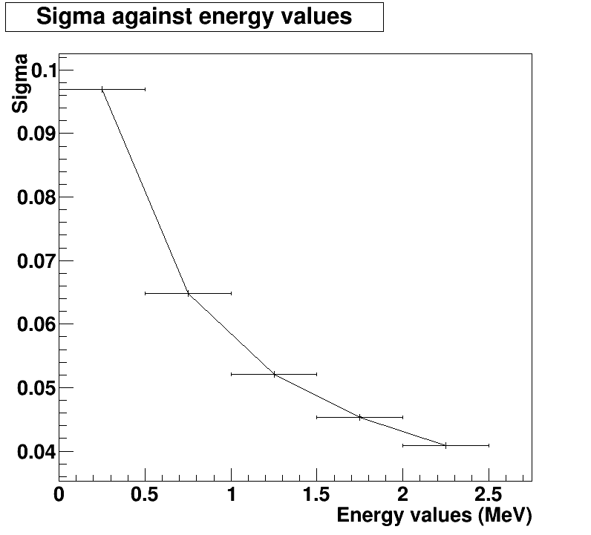

Figure : A comparison of Sigma against energy values (MeV) for energy only cuts.

The Sigma against energy shows a much more consistent downward curve that shows a decrease in change as the energy interval increases. This graph shows a strong negative correlation between the energy intervals raising and the distribution away from the mean decreasing with it. This shows that the distribution width decreases as the energy interval increases.

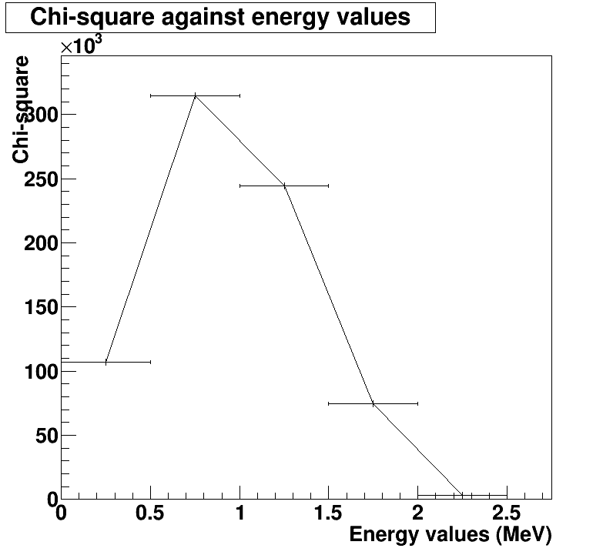

Figure : A comparison of Chi square against energy values (MeV) for energy only cuts.

The Chi-square against energy gives less of a coherent pattern. With the exception of the first point there shows a downward trend however with so few data points available the first point cannot be ruled out as an anomaly and thus a pattern cannot be given. More points are required to strengthen (or disprove) the evidence that chi-square decreases as the energy intervals increase suggesting that a gaussian distribution fit becomes more accurate at higher values.

Given the evidence its suggests that RAT is better at reconstructing events at higher energy intervals in terms of being able to model said distribution using a gaussian and giving a smaller spread of data as evidence by the decreasing sigma value as the energy interval increases. With these two factors taken into account it suggests that the reconstruction simulations are more accurate at higher energy values. There is however more deviation from the mean as energy intervals tends toward the central values and using the analysis of mean it suggests that the algorithms are most evenly reconstructed at lower energy values (then followed by the higher values). From the data provided it shows that a bias exists in terms of the mean and is constant across all energy values resulting in a negative value for all mean values extracted. This bias in mean is most likely a result of energy being lost within the AV to its surroundings , weather that is in the form of heat, absorbed by other particles within the AV in terms of collisions or not meeting the required threshold to be artificially detected by the PMTs. As mean is consistently negative across all values it is possible that the algorithms used do not yet fully compensate for energy loss within the system. As reconstruction requires both energy and range it is worth studying energy distributions at different radii as well as the opposite: studying range distributions at different energies. By doing this it may give a better insight into the biases and distributions that occur within the reconstruction.

**Analysis part three: 2 neutrino double beta decay simulations using energy and range**

By writing a more detailed program within root a total of 55 histograms have been produced, these have been divided up into 25 histograms at various energy and range cuts, 15 graphs which compare the mean, sigma and chi-square against energy for 5 different range cuts and an additional 15 which compare the mean, sigma and chi-square against range for 5 different energy cuts. These graphs will be used to provide a greater in-depth analysis than the previous section and will be better used to zoom in on key components that effect the accuracy of reconstruction to the initial construction. In order to avoid repetition not all the graphs mentioned will be included although will be available upon request.

Below the Mean, Sigma and Chi square value have been extracted are condensed into three separate tables for quick and easy comparison:

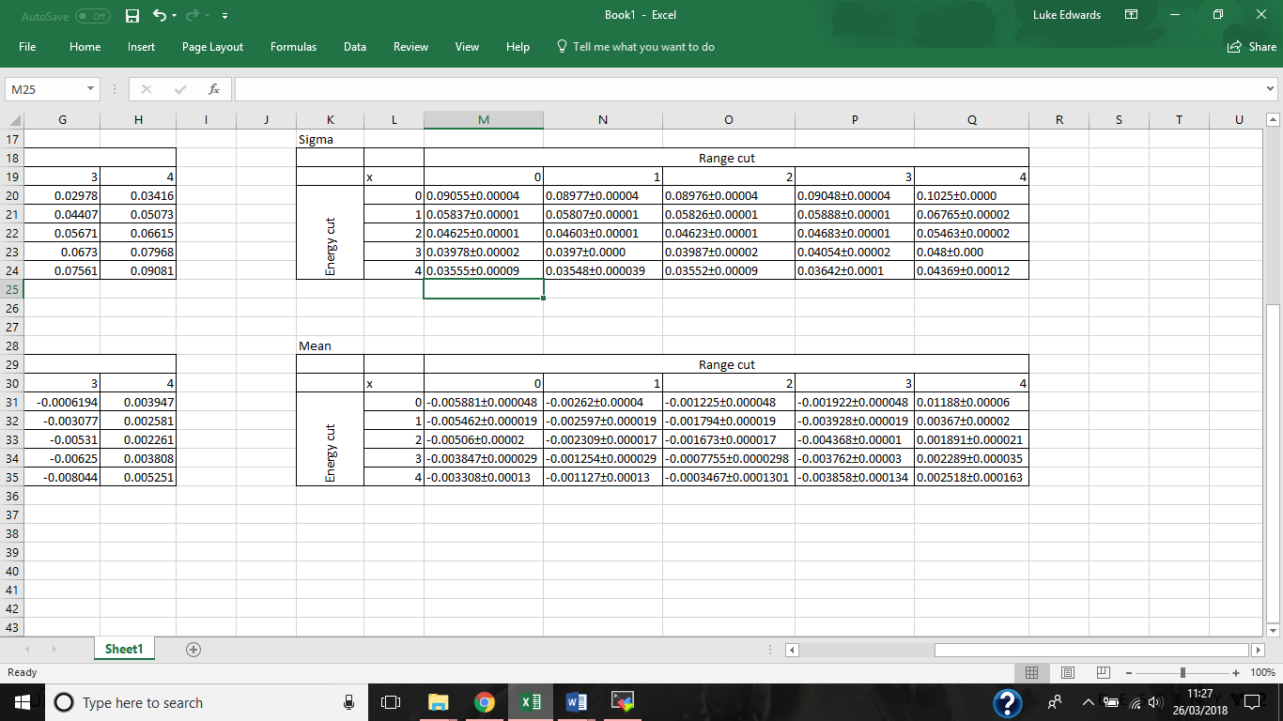

Table : Mean values for both energy and range cuts.

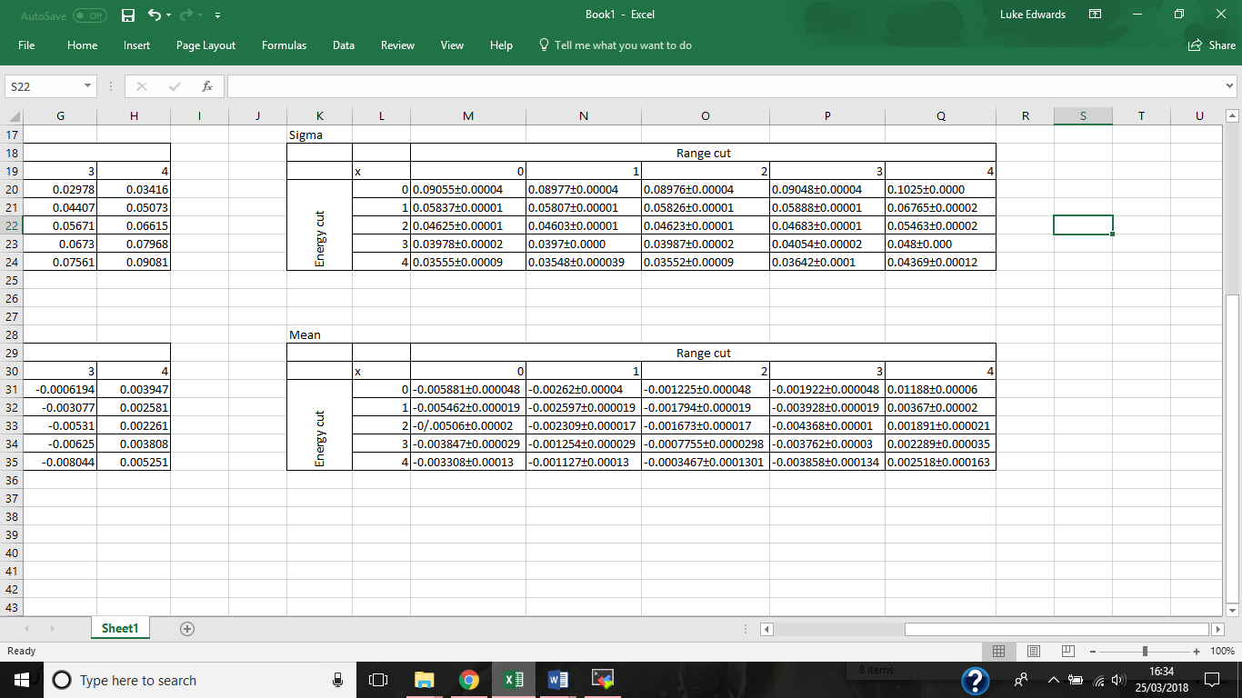

Table : Sigma values for both energy and range cuts.

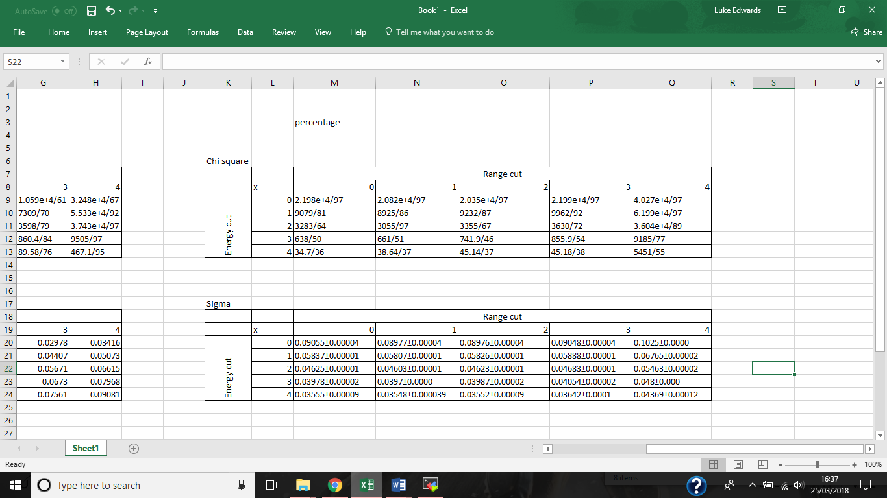

Table : Chi square values for both energy and range cuts.

The Mean comparison table shows that the Mean becomes increasingly more accurate as energy increases for range cut 0 and 1 with range cut 2 roughly following the same pattern with the exception of hist02 which has a lower than expected value. However this pattern does not extend to the range cuts 3 and 4. The trend that range cut 3 starts with a low negative mean value which then goes on to increase further away from the ideal 0 value peaking at -0.004368±0.00001 before increasing slightly and slowing a rough plateau at around -0.003858±0.000134. The graph of range cut 3 which is given below gives a rough downwards curve in direct contrast to the curves given for range cut 0, 1 and a lesser extent 2. Range cut 4 shows a better defined curve similar to that of range cut 3 giving the same downwards curve and showing a better defined plateau at around 0.04369±0.00012. For range cut 4 all values are positive hence in this case the first energy value given is the least accurate similar to range cuts 0 and 1 and becomes more accurate as energy increases following the downwards curve, the curve then increases slightly to the previously mentioned value of 0.04369±0.00012. The graphs of this Mean analysis are given below:

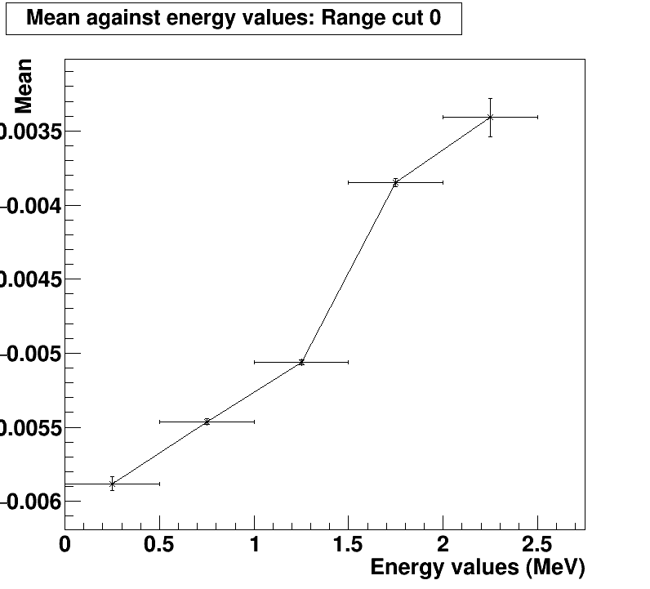

Figure : Range cut 0 shows the Mean becoming more accurate as energy increases.

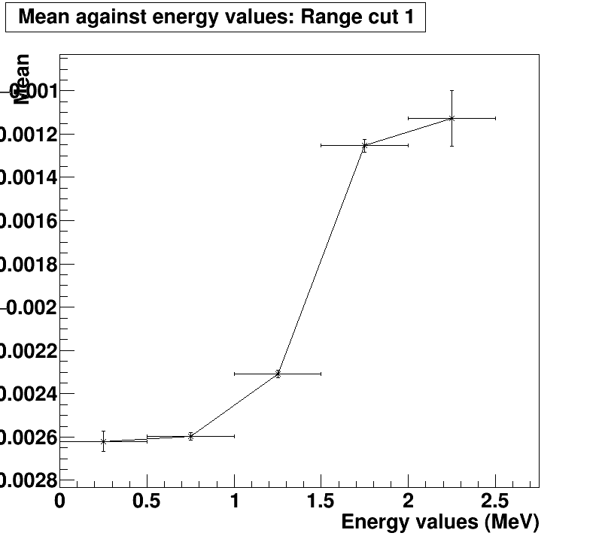

Figure : Range cut 1 shows the Mean becoming more accurate as energy increases similar to that of range cut 0.

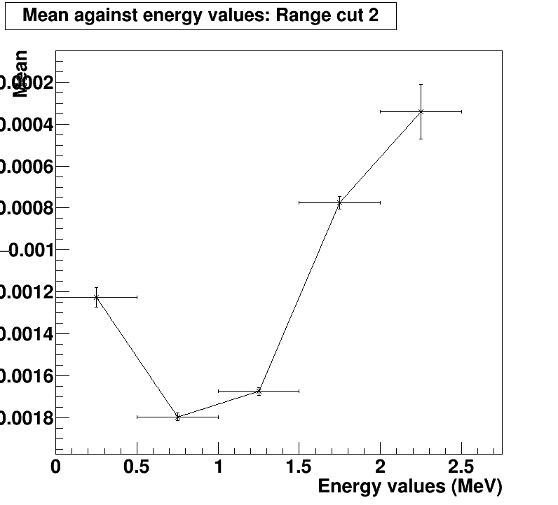

Figure : Range cut 0 shows the Mean becoming more accurate as energy increases with the exception of the first energy value which has a lower mean than expected.

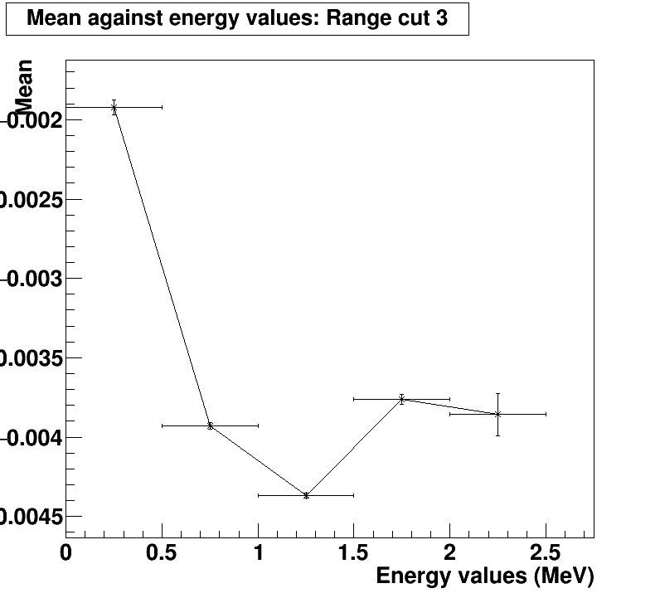

Figure : range cut 3 showing an opposite trend to that of the previous cuts becoming more inaccurate as energy increases with a maximum mean of -0.004368±0.00001 before plateauing at -0.003858±0.000134.

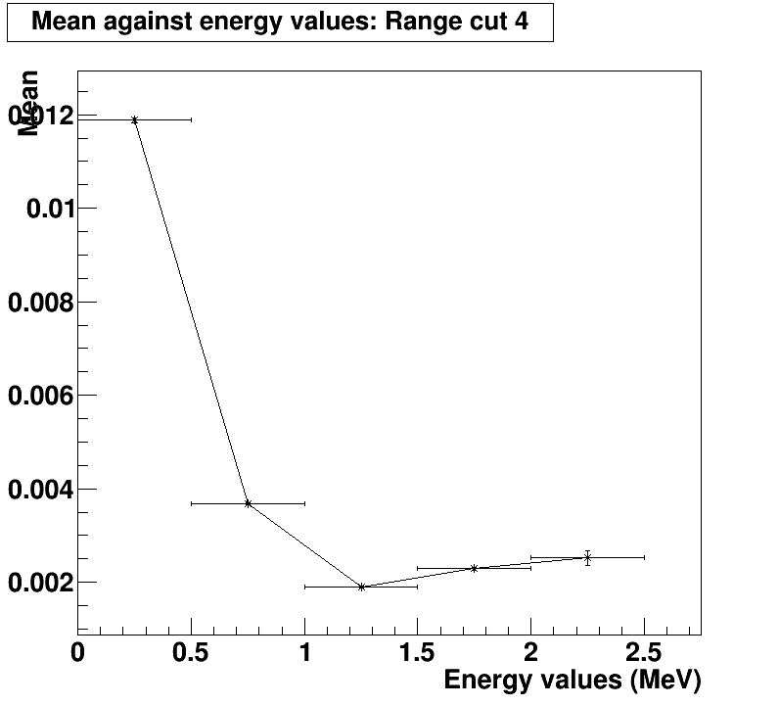

Figure : Range cut 4 shows the opposite trend to that of range cut 0, 1 and a lesser extent 2 showing a downwards curve before plateauing at 0.002518±0.000163. Range cut 4 is the only range cut to have positive mean values.

For each of the energy cuts the range cuts 0-4 show a negative value while range cut 5 shows a positive value for each of the energy cuts. Extrapolating from this and from purely a mean perspective the histograms and most accurate at high energy values and at a range cut of around 2 or 3 which translates to the 4052.43mm - 5105.75mm region. It is possible that a more accurate mean lays between range cut 3 and 4 where the mean transitions from a negative value to a positive value, although more cuts will be required to prove this. Extrapolating further given that range cut 4 is the only cut to give positive values it is possible that there are additional factors within this range that will decrease the accuracy of the mean. This is explored in some detail down below.

The sigma comparison shows a consistent patterns across both range and energy cuts. The range cuts shown by figure 24 below shows a downwards curve where sigma decreases as energy increases showing that the distribution decreases and thus the algorithms become more accurate as energy increases. This is true for all range cuts and thus not all graphs will be included to avoid repetition.

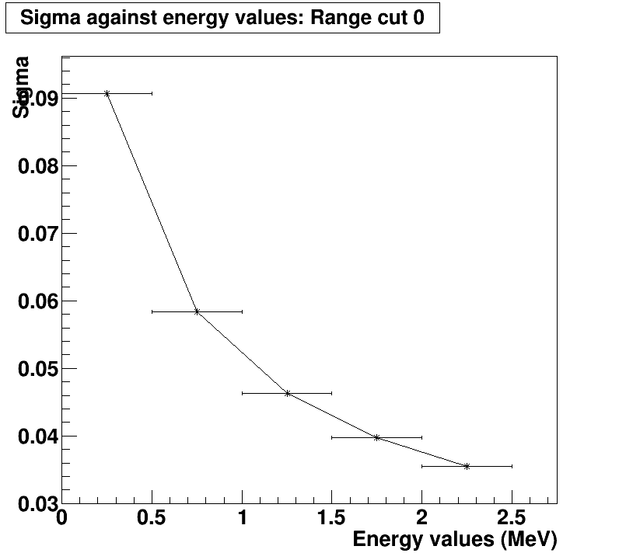

Figure : Sigma against energy values range cut 0. This curve is consistent across all range cuts.

As for energy cuts a pattern exists that is consistent across all energy cuts although different to that given by the range cuts. This pattern (shown below by figure 25) shows a slight decrease in sigma and by extension the width of the distribution as range increases before raising slightly at energy point 4 and then jumping by a huge value for energy value 5. This jump which is consistent across all energy cuts suggests that there are additional factors within the upper ranges (4052.43mm – 5500mm) that result in an increase in sigma and negatively effect the accuracy of the reconstruction in comparison to the true energy. This factors effects have been previously mentioned within the mean analysis as a flip in mean values can also be seen within the outer ranges (5105.75mm-5500mm) providing further evidence for this unknown factor.

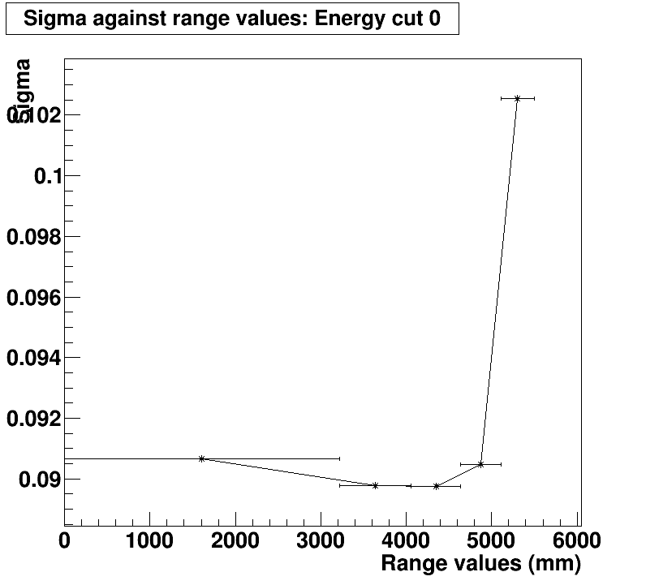

Figure : Sigma against range values energy cut 0. This pattern showing a large increase in sigma for range value 5 is consistent across all energy cuts.

Finally Table 8 shows the chi square value for each of the 25 histograms produced and follows the trend provided by Tables 6 and 7 in which range cut 4 shows a spike of inaccuracy. The goodness of fit increases as the energy cuts increase which reinforces the results that reconstruction is more accurate at higher energy values. As for range the chi square value seems to be roughly consistent as the range increases. In some cases such as energy cut 3 and 4 chi square will increase ever so slightly as the range increases possibly showing a preference for low range values but this trend is minimal and doesn’t always apply and as such a consistent chi square across range cuts 0 to3 is more accurate. A pattern that is consistent across each of the energy cuts (as shown below by figure 27) is the massive increase which occurs in the range cut 4 (5105.75mm – 5500mm) area. This again supports the statements made within the mean and sigma analysis that there are additional factors within the upper ranges (4052.43mm – 5500mm) that result in a flip in the mean value (going from negative to positive), an increase in sigma and a huge increase in the chi square value which negatively affect the accuracy of the reconstruction in comparison to the true energy. It is worth noting that histograms [4][0], [4][1], [4][2] and [4][3] (energy cut 4, range cut 0,1, 2 and 3) have a chi square value of 34.7, 38.64, 45.14 and 45.18 respectively which is lower than the statistical value for Chi square of 61.581 for 36 degrees of freedom, 62.883 for 37 degrees of freedom and 64.181 for 38 degrees of freedom and thus can be accepted as gaussian distributions.

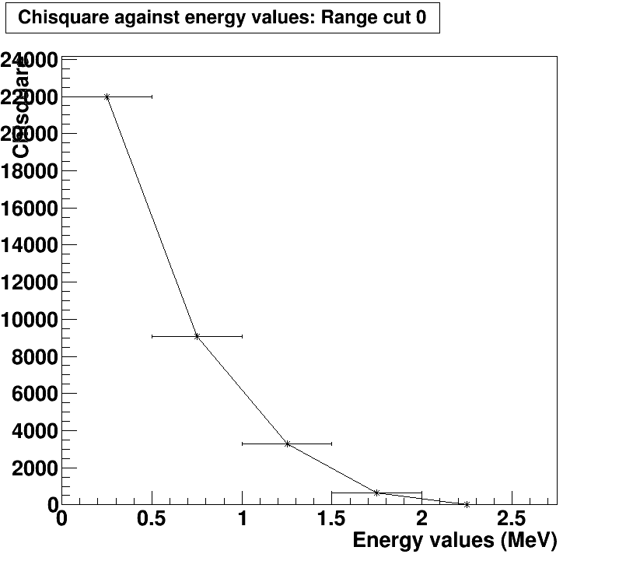

Figure : Chi square against energy values, range cut 0.

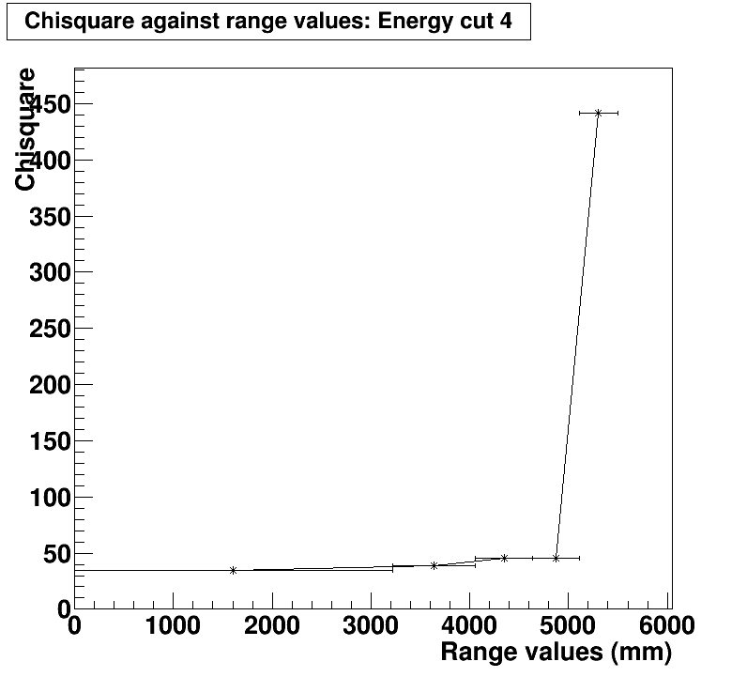

Figure : chi square against range values, energy cut 4. Shows a large increase for range value 5.

The increase in inaccuracy which is consistent across each of the three graphs for range cut 4 suggests that there are underlying factors for which the algorithms struggle to recreate the Energy at this range. Possible factors for this may be that the fictitious limit that has been introduced at 5.5m is not emphasised enough and that a stronger limit, maybe at 5.4m or sooner, may have to be introduced. A possible cause for this inaccuracy may be due to the bottle neck structure within the acrylic vessel. The bottle neck which is a necessary component to funnel the electronics can cause a dissymmetry within the otherwise symmetrical sphere of the AV, this means that the y- component (height) of the range may have some bias’s at the larger ranges due to both a lack of consistency and PMTs to mirror the opposite side of the AV at the bottle neck. This is one possible factor for the inaccuracy shown at range cut 4. In order to provide evidence for this an additional 5 graphs are produced with the same energy values as previous but a further reduced range with a maximum limit of 5.4m:

|  |  |  |  |  |  |  |
| --- | --- | --- | --- | --- | --- | --- |
| Energy cut | Mean RC4 | Mean RC reduced | Sigma RC4 | Sigma RC reduced | Chi square RC4/ndf | Chi square RC reduced/ndf |
| 0 | 0.01188 ± 0.00006 | 0.007313 ± 0.000053 | 0.1025 ± 0.0000 | 0.0968 ± 0.0000 | 4.027e+4/97 | $$3.8 × {10}^{4}/97$$ |
| 1 | 0.00367 ± 0.00002 | 0.0004749 ± 0.000021 | 0.06765 ± 0.00002 | 0.06318 ± 0.00002 | 6.199e+4/97 | $$5.006 × {10}^{4}/94$$ |
| 2 | 0.001891 ± 0.000021 | -0.00105 ± 0.00002 | 0.05463 ± 0.00002 | 0.05068 ± 0.00001 | 3.604e+4/89 | $$3.194 × {10}^{4}/82$$ |
| 3 | 0.002289 ± 0.000035 | -0.0007855 ± 0.000033 | 0.0480 ± 0.000 | 0.0443 ± 0.0000 | 9185/77 | 8710/66 |
| 4 | 0.002518 ± 0.000163 | -0.0009458 ± 0.000150 | 0.04369 ± 0.00012 | 0.04005 ± 0.00011 | 5451/55 | 399.8/45 |

Table : Comparing mean, sigma and chi square values when the upper range limit of 5.5m is reduced to 5.4m.

The table above compares the Mean, Sigma and chi square value of range cut 4 (denoted RC4) against another cut where the upper range limit is reduced to 5.4m (denoted RC reduced) RC4 ha a range of 5105.75mm-5500mm while RC reduced has a range of 4989.16mm-5400mm. Both RCs have the same volume of $1.394 × {10}^{11}mm^{3}$.

Table 9 shows that each factor compared (mean, sigma and chi square) are reduced in every case, however the values all remain within the same magnitude on the original RC4 and are still significantly higher than their range cut 3 counterparts While reducing the maximum range may have been a step in the right direction to reducing the Mean, sigma and chi square at the higher ranges it is possible that either the maximum range needs to be reduced further than the self-imposed 5400mm limit or that the maximum range is not the only component effecting the results.

By comparing tables 6, 7 and 8 against table 5 and comparing the 55 graphs produced using energy and range against the original 8 using energy only it is possible to analyse the effect that range has on the accuracy of reconstruction as well at the mean, sigma and chi square value of the distribution.

Comparing the output of simultaneous range and energy cuts against energy only cuts shows that for the initial two comparisons (referring to hist0 and hist1) that the mean is more accurate when range is not restricted. However when mean is restricted, particularly to the 4052.43mm – 4638.88mm region the mean will decrease back to the ideal value at a faster rate and as such hist22 (energy cut 2 with range cut 2) and onwards have a lower mean that their unrestricted range counterparts. This comparison shows that only when the range is restricted to the 4052.43mm – 4638.88mm region that the dual energy and range cuts give a more accurate mean than the unrestricted range mean and that range cuts 0, 1,3 and 4 show a greater deviation that the overall mean for that energy cut. Given this it suggests that the algorithms are most accurate when using a middle range.

In both cases the sigma value gives the same pattern, showing a downward deaccelerating curve in the positive direction displaying that sigma value decreases with the energy cut regardless of range. However it also appears that while the pattern and visual curve remain constant the range does appear to have an effect on the numerical data, Having range restrictions appears to reduce the overall sigma value with the exception of range cut 4. Thus It is shown that by having a range restriction it is possible to filter out the undesirable data that is found within the outer ranges and give a smaller distribution and my extension a more accurate reconstruction.

In terms of chi square it is clear that the addition of range cuts has reduced the chi square value significantly for the corresponding value in energy. In both cases it appears that some factor plays a role in increasing the chi square value somewhere between 5105.75mm – 5500mm (range cut 4). In the case of energy only cuts this factor will increase the chi square value across all energy values as nothing is put in place to prevent this factor. By making cuts on both energy and range it is somewhat possible to restrict this factor into range cut 4 allowing range cuts 0 through 3 to have significantly lower values and in some cases (energy cut 4) allow the chi square value to be low enough to be a statistically good fit.

**Conclusion**

The algorithms used within the reconstruction of the energy given initial energy input and the accuracy associated with them are dependent on many factors including energy and range. While energy and range can be restricted to help with the accuracy there are other factors that cannot be accounted for given the scope of this report and the limited access given by RAT/root and the resources provided by Queen Mary University of London. Given the Access that Is at the disposal of this report it is possible to show the extent that both energy and range effect the accuracy of reconstruction via the mean, sigma and chi square of the entries given and studying the change in accuracy when cuts and limits are applied. For 0 neutrino double beta simulations the results show that mean, sigma and chi square values seem to be consistent for low ranges with some unknown factor causing inconsistencies with the higher 2 range intervals. When studying the entries across the entire spectrum results show that entries are notably more clustered towards the central peak of the distribution as well at the tail ends. Having such a cluster near the central point of the distribution would be a good sign of accurate reconstruction and likely has a notable improvement to the sigma value of the graph however this results in a significantly higher chi square value and such a positive effect is promptly undone by the cluster of entries located at the tail ends of the distribution. It is also shown that low levels of entries exist at the far tail ends of the distribution that have a notable effect on the goodness of fit as a gaussian distribution, when the full distribution is fixed to ±0.3 MeV there is a small but notable decrease in the chi square value. The remaining value is still magnitudes higher than the required statistical chi square value for the corresponding degrees of freedom using a 5% significance. In order to help with the accuracy of reconstruction the entries are sorted into 5 separate energy cuts in an attempt to isolate the factors that result in inaccuracies with the most apparent being the extremely high chi square value. By bringing in energy only restrictions trends for improved accuracy can be spotted at different points within the limitations, for example each of the sigma and chi square values are more accurate at higher energy while mean shows no noticeable pattern peaking at $-2.031 × {10}^{-3} ±8 × {10}^{-6}$ for energy cut 2. The negative mean value is believed to be as a result of energy being lost within the system or to the systems surroundings and that the algorithms used do not fully compensate for this energy loss. The chi square value continues to improve as the energy intervals increase by dropping several orders of magnitude. The change in chi square is so extreme that the chi square value is able to go from a $3.148 ×{10}^{5}/97$ to a value much closer to the acceptable value with a value of 3469/94. Given these factors the restrictions using energy along are not restrictive enough to give a complete view on factors effecting the accuracy of the reconstruction as range is not restricted. By incorporating both energy and range cuts into the reconstruction distributions some of the factors are able to be further isolated. This takes the form of range cut 4 where the tables 6, 7 and 8 show that the mean, sigma and especially chi square take massive jumps when within this range. By filtering out this range from the other cuts it is possible to reduce mean, sigma and chi square values down further. Using the values of separate energy and range cuts it is possible to reduce the chi square value down to acceptable values allowing the energy range cut histograms [4][0], [4][1], [4][2] and [4][3] (energy cut 4, range cut 0,1, 2 and 3) of 34.7, 38.64, 45.14 and 45.18 respectively which is lower than the statistical value for Chi square of 61.581 for 36 degrees of freedom, 62.883 for 37 degrees of freedom and 64.181 for 38 degrees of freedom and thus can be accepted as gaussian distributions.

**References**

[1]: SNOLAB institute, About SNO+. Available URL: https://snoplus.phy.queensu.ca/About.html [Accessed 27/03/18]

[2]: SNOLAB institute, Information and time schedule upgrades to SNO+. Available URL: <https://snoplus.phy.queensu.ca/News.html> [Accessed 27/03/18]

[3]: AV properties: Y.Suzuki and Y. Totsuka (28th Jul 1999). Neutrino physics and astrophysics. North Holland, Elsevier

[4]: Wikipedia, Tellurium properties. Available URL: <https://en.wikipedia.org/wiki/Tellurium> and <https://en.wikipedia.org/wiki/Isotopes_of_tellurium> [Accessed 27/03/18]

[5] Jefferson Lab, Tellurium half-life. Available URL: <https://education.jlab.org/itselemental/iso052.html> [Accessed 27/03/18]

[6]: Wikipedia, Neutrinoless double beta decay Feynman diagram. Available URL: <https://en.wikipedia.org/wiki/Double_beta_decay#Neutrinoless_double_beta_decay> [Accessed 27/03/2018]

[7]: Schechter, J.; Valle, J. W. F. (1982). "Neutrinoless double-β decay in SU(2)×U(1) theories". [Physical Review D](https://en.wikipedia.org/wiki/Physical_Review_D). 25 (11): 2951–2954. [Bibcode](https://en.wikipedia.org/wiki/Bibcode):[1982PhRvD..25.2951S](http://adsabs.harvard.edu/abs/1982PhRvD..25.2951S). [doi](https://en.wikipedia.org/wiki/Digital_object_identifier):[10.1103/PhysRevD.25.2951](https://doi.org/10.1103%2FPhysRevD.25.2951).

[8]: Wikipedia, Linear alkyl benzene scintillator. Available URL: <https://en.wikipedia.org/wiki/Linear_alkylbenzene#cite_note-8> [Accessed 27/03/18]

[9]: SNOLAB Institute, Graph of Large Angle MSW Oscillations. Available URL: <https://snoplus.phy.queensu.ca/Solar_Neutrinos.html> [Accessed 27/03/18]

[10]: SNOLAB Institute, PEP neutrino flux. Available URL: <https://snoplus.phy.queensu.ca/Solar_Neutrinos.html> [Accessed 27/03/18]

[11]: Lunardini, C., and Smirnov, A. Yu. Astropart. Phys. 21 703 (2004).

Kernan, P.J., and Krauss, L.M., Nucl. Phys. B 437 243 (1995)

[12]: Kernan, P.J., and Krauss, L.M., Nucl. Phys. B 437 243 (1995)

[13]: Araki, T. et al, hep-ex/0406035, (2004)

[14]: S. Andringa et al. Current Status and Future Prospects of the SNO+ Experiment

[15]: Palisade, Monte Carlo simulations. Available URL: <http://www.palisade.com/risk/monte_carlo_simulation.asp> [Accessed 27/03/18]

[16]: Hindawi, Use of Monte Carlo simulations within SNO+. Available URL: <https://www.hindawi.com/journals/ahep/2016/6194250/> [Accessed 27/03/18]

[17]: Measurement of the Rayleigh Scattering Length and Background contributions during early data taking phases at SNO+, Stefanie Langrock, School of Physics and Astronomy Queen Mary, University of London 2016. Available URL: <http://pprc.qmul.ac.uk/sites/default/files/Research/Thesis_0.pdf> [Accessed 27/03/18]